Organization Information
Organization Name:
Organization Location:
Organization Primary Contact Name:
Primary Signatory:
Financial Contact:
Beneficiary Contact (if applicable):
Board Chair:
Does this grant include a Fiscal Sponsor?
If Yes, please provide narrative details of the Fiscal Organization (text box provided)
Additional questions:
- Fiscal Org Name:
- Fiscal Org Location/Address:
- Fiscal Org Contact Name:
- Fiscal Org Signatory Name:
Grant Information
Project Title (One sentence):
Project Summary (please be brief):
Amount Requested:
$0.00
Total Project Budget:
$0.00
What would Harold K.L. Castle Foundation funds be used for? Describe in some detail the specific activities of the project for which you are requesting funding. Your budget should relate to this set of activities. Please indicate the number of beneficiaries you expect to serve or reach through this project.

Length of Project (in months):
0
Project Outcomes
What are your project outcomes (list at least three)? These are the goals and results you hope to accomplish with your community service. How do you want your project to make a difference in your community?
Outcome 1:
Outcome 2:
Outcome 3:
Outcome 4:
Outcome 5:

Key Project Activities
Describe in some detail the major activities under each of the outcomes outlined above, and why you feel they will help you accomplish them. Please also include the data, metrics, and/or evidence base you will use to help determine progress on these activities toward achieving your outcomes. Please note, your budget should relate to this set of activities.

Have you applied to other funders for this project and if so, to whom, for how much, and by what date is a decision expected?

Please list current funding commitments (cash, not in-kind) for this project. By "commitments" we mean monies already received, or binding signed commitments.

Project Experience - Briefly describe the experience and skills of the organization and key staff members or volunteers related to the project for which you are requesting funding. Please also identify any other organizations that are doing similar work and explain what distinguishes your organization's approach from theirs.

List project risks and how you will manage them. This will help us to understand the obstacles to your success.

We want your feedback. How did you like the online process? Was it user-friendly? What was frustrating about it? Please share any suggestions or comments that could help us improve the online application process in the future.

Proposal Related Documents
Please select your organization type:
Choose an item.
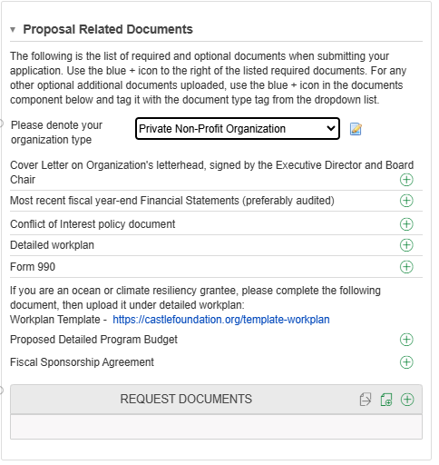
Important Instructions: When you open the online Mission Aligned Grant Application Card, a list of required and optional documents will be shown. Required documents differ according to the Organization Type you choose from the drop-down above.
You will use the green upload + icon to the right of the listed required documents. For any other optional additional documents uploaded, use the green upload + icon in the REQUEST DOCUMENTS component box and tag it with the document type tag from the dropdown list.

(See Sample Here for Non-profits)

